4. Write a pig script to find no of complaints filed with product type has "Debt collection" for the year 2015

//query

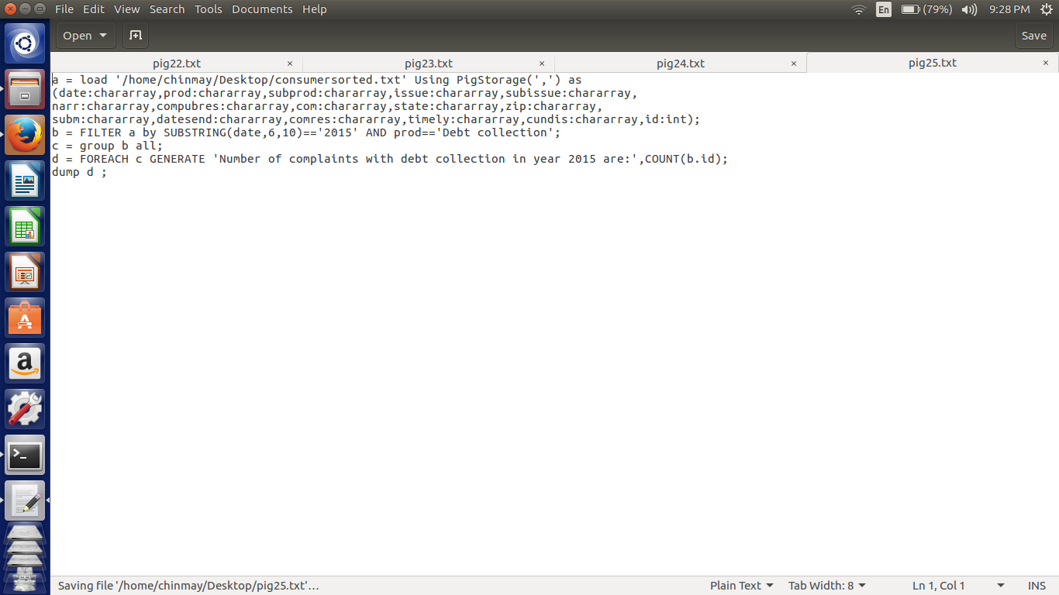

Here in this script first we are loading the file according to respective datatypes.

We have used the substring and compared with the last for digits to be 2015. And also used the AND operator to check for the Debt collection

The group by all and count ids to count the debt collection in the year 2015.

//implementation

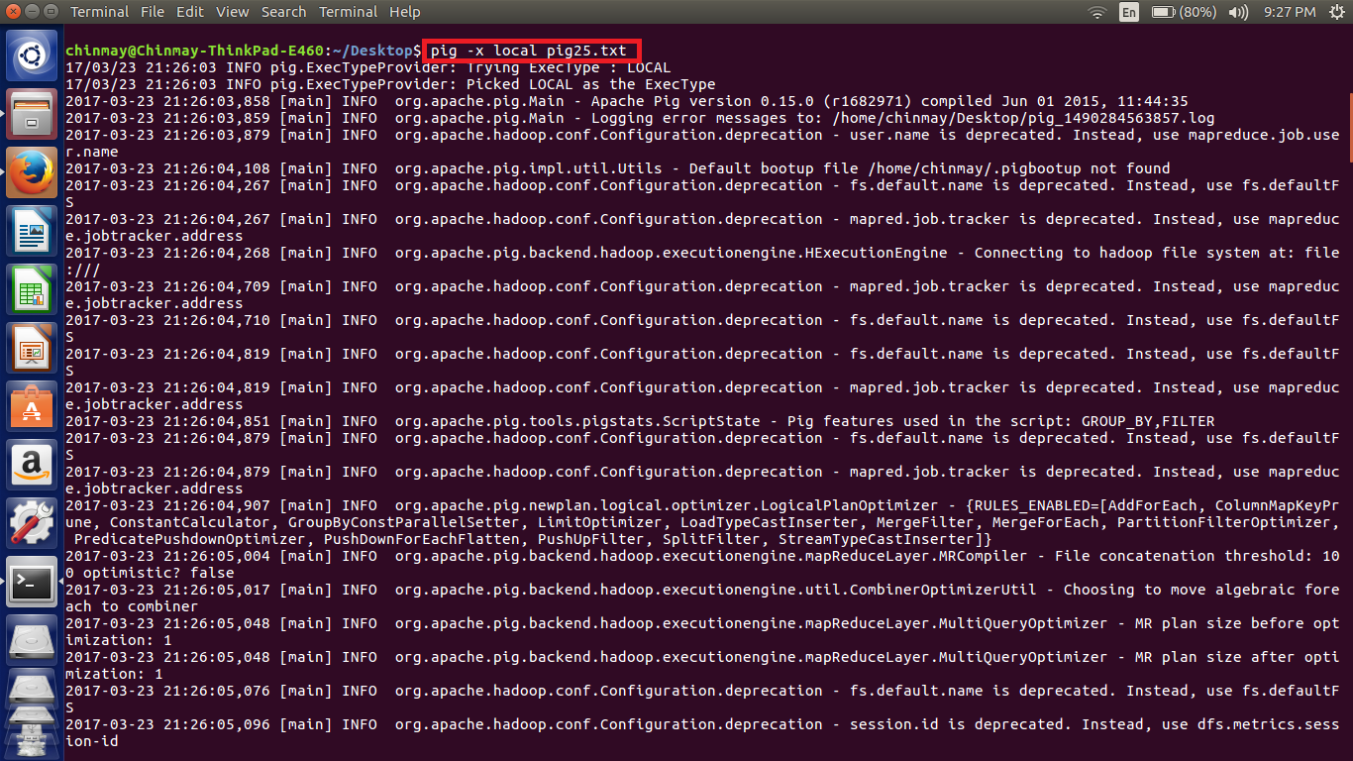

//output

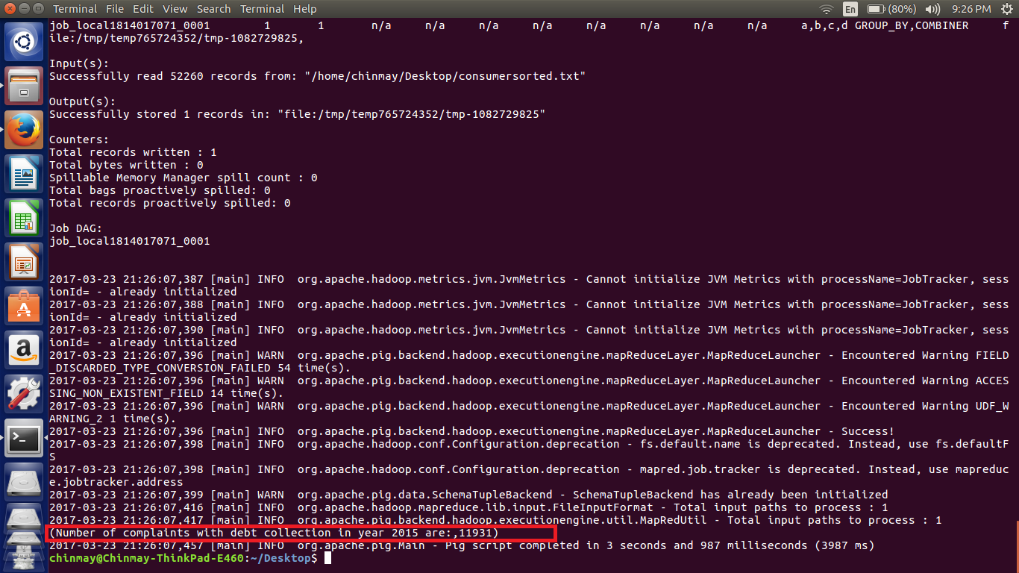

***NOTE - The file used for the implementation is also attached.***